CURRICULUM VITAE
Of THARMARETHINAM LOJITHAN

General: Date of Birth : 28th September 1988.
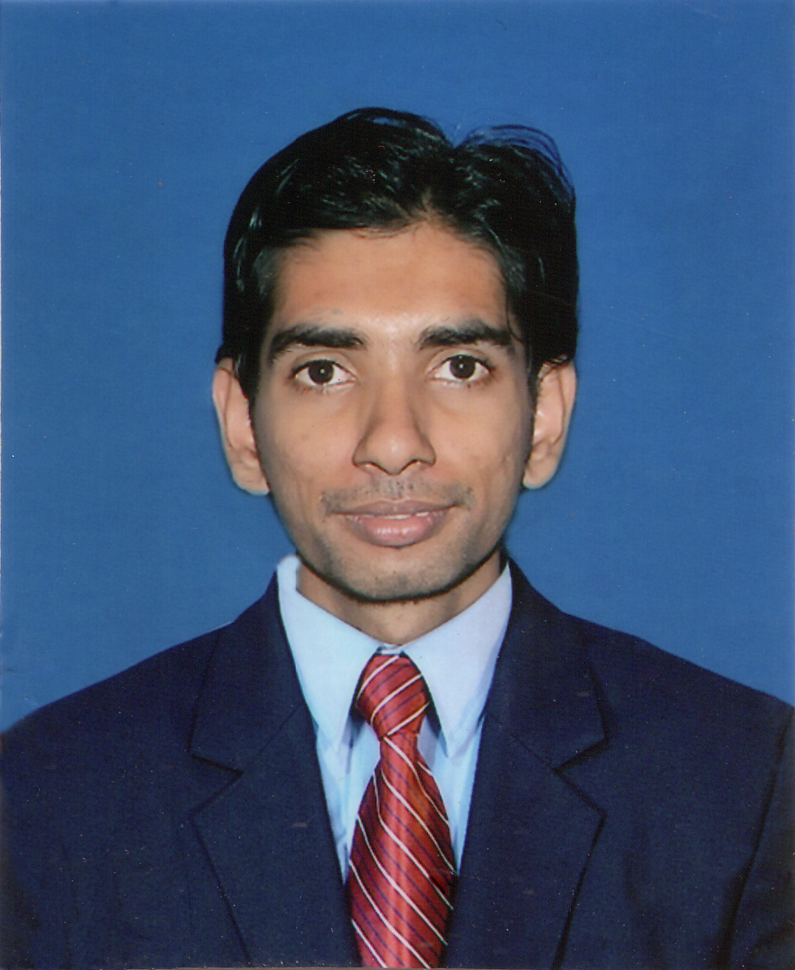
Gender : Male.

Religion : Hindu.

Civil status : Single.

Nationality : Sri Lankan.

Address : No 19, 1st Cross, koolavady east, Batticaloa, Sri Lanka.

N.I.C No : 882722899 V.

Contact No : +94778487799

E-Mail address : loji007@ymail.com

Education: G.C.E (O/L) in December 2004 Bt/Hindu College
Index No: 40557375
Mathematics : A
Religion : A
Dance : B
Technical subject : B
Tamil Language : C
Tamil (optional) : C
Science and Technology : C
Social studies : C
English : S

G.C.E (O/L) in December 2005 Bt/Hindu College
Index No: 54669545
English : C

G.C.E (A/L) in June 2009 Bt/Hindu College
Index No: 3214761
Combined Maths : S
Physics : S
General knowledge : 72

Professional qualification

- One year experience in Slon depo as a computer operator.
- Three years working experience in computer hardware & software development & web designing.
- Successfully completed the three months training programme in Hotel management Front office operations conducted by S.L.I.T.H.M.
- Successfully completed the Diploma in PC professional in CSC computer Education.
- Successfully completed the Computer Hardware training programme at Divisional Secretariat, Manmunai north.
- Successfully Completed Diploma in Desktop Publishing & Offset Printing at St.Johns Vocational Training Centre.
- Completed ASAP training programme in USAID

Language Skill

- Tamil Mother Tongue.
- English Reading, Writing and normally speaking skill.
- Sinhala Reading, Writing and normally speaking skill.

Extra Curricular Activities

- Served as a School Prefect at Bt/Hindu College.
- Attended a leadership work shop and obtained certificate.
- Participated many Tamil day competition & English day competition.

Non Related Referees

Mrs.S.Raveendran Mr.G.Sharangan
Teacher, Executive Officer
Hindu college, Alliance Finance company.
Batticaloa. Batticaloa.
T.P.No:0652222290 T.P.No:0771090168

I do hereby certify that the above particulars given by me are true and accurate to best of my knowledge.

………………… .…………....
T.Lojithan Date

